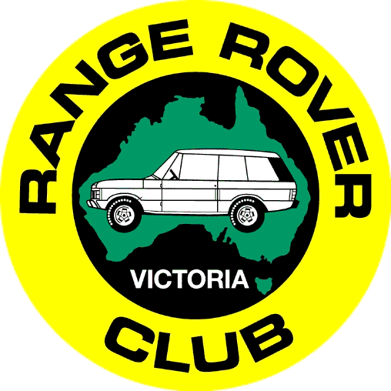
Range Rover Club of Australia,
Victoria Branch (Inc)
PO Box 248
Deepdene Delivery Centre VIC 3103
ABN 32 585 770 245

Membership Application

I/We desire to become members of the Range Rover Club of Australia Victoria Branch (Inc) and agree to be bound by the rules of the Club.

Name: Mr/Mrs/Ms _________________
Spouse/partner: Mr/Mrs/Ms _________________
Postal Address:
P/Code:
Telephone - Home:
Telephone - Mobile/s:
Email address:

Preferred presentation of names (first & family) on your Club name badges:
Name 1 (member):
Name 2 (partner):
Name badges can also be ordered for children @ $10 each – please list their preferred names:

Vehicle Details:
Vehicle Make: Model:
Registration No: Colour:

Signed (Applicant): Date:

Payment Details:

The Club membership year runs from 1 July to 30 June and the fees are $135 one-off joining fee (which includes driver training) plus $135 annual membership fee. Annual membership fees are calculated on a pro-rata basis, depending on the joining date. For example, if you join half way through the year, you will only pay 6 months annual membership fees.
Enquiries to the Membership Secretary 0411 028 090 or memberships@rangeroverclub.org.au

Credit Card Payment VISA Mastercard

Exp: ____/_____

Signature: _________________________________________

